PKS Pink Snapper *Pagrus auratus*

sea bream family (Sparidae) and are related to species such as black bream *(Acanthopagrus butcheri)* and tarwhine or silver bream *(Rhabdosargus sarba* Pink snapper are ‘demersal’ or bottom-dwelling but also spend some of their lives in the mid- to upper water levels. Adults are found out to depths of 200 to 300 metres along the continental shelf, while juveniles are common in bays, inlets and estuaries that provide important nursery areas. They have a broad-ranging diet and feed on small fish, crustaceans, worms, molluscs, jellyfish, echinoderms (such as sea stars and sea urchins) and algae.

**snappers Snapper *Pagrus auratus*** The natural diet of snapper includes crabs, sea urchins, scallops, clams and mussels. Echinoderms, teleosts, crustaceans and molluscs made the greatest overall contributions to the diet of Pagrus auratus on the basis of both their frequency of occurrence in the gut contents and their volumetric contributions to those contents. While ophiuroids (belonging entirely to the family Ophiuridae) and echinoids were the two major echinoderm classes in the gut contents of Pagrus auratus, the former was ingested far more frequently and made a far greater contribution to those of smaller

fish (<400 mm) from the lower west coast than to those of large fish from both this region and the mid west coast. The decapod component of the diet of P. auratus was always overwhelmingly dominated by crabs, which represented a number of different families, such as the Portunidae and the Majidae. With the two most important dietary groups of molluscs

consumed by Pagrus auratus on the lower west coast, gastropods tended to be ingested slightly more frequently and in greater volumes by larger fish (i.e. >400 mm), whereas the reverse was the case with bivalves. While polyplacophorans and cephalopods made a small but appreciable contribution to the diets of larger P. auratus from the lower west coast, these two groups were either absent or present in only small volumes in the gut contents of both small P. auratus from the lower west coast and larger individuals from the mid west coast. On the mid west coast, where smaller Pagrus auratus could not be obtained, echinoids and teleosts were by far the most important contributors to the diets of this species and collectively contributed far more to those diets than to those of the corresponding size

range of fish on the lower west coast. On the lower west coast, an increase in the body size of P. auratus was accompanied by a dramatic decline in the dietary contribution made by ophiuroids, from as high as ca 63% in the smallest fish, and an increase in that of teleosts, with asteroids becoming ingested by the larger individuals and contributing as much as 25% to the diets of the largest P. auratus. The dietary contributions of echinoids and gastropods tended initially to increase with body size and then decline in the larger individuals. These size-related changes were largely driven by a very pronounced and progressive shift in the size and type of prey from small ophiuroid echinoderms (brittle stars) by the smallest individuals to substantial consumptions of brachyuran crabs, teleosts and echinoid echinoderms (sea urchins) and ultimately also asteroid echinoderms (starfish) by the largest individuals. The ingestion of very large amounts of small and slow-moving ophiuroids by small P. auratus contrasts with the situation elsewhere, with these echinoderms never being found in the gut contents of such P. auratus in a gulf in South Australia (Saunders

et al., 2012) and only occasionally in a gulf and estuary in New Zealand (Colman, 1972; Usmar, 2012). However, this shift from the consumption of such large volumes of ophiuroid echinoderms by the smallest fish to other prey by larger and older fish almost certainly reflects, in part, a change from foraging over soft sediments to areas over and around reefs. The view that small snapper feed over soft substrata is entirely consistent with the results of

studies of the 0þ of this species in a large marine embayment in South Australia As potential alternative prey for small P. auratus, e.g. polychaetes and amphipods, are relatively abundant

in Cockburn Sound (Oceanica, 2007), it is proposed that brittle stars are targeted by small snapper in Cockburn Sound, because those echinoderms would be particularly visible in the turbid waters of this embayment. On the lower west coast of Australia, the increased ingestion of teleosts and crabs by Pagrus auratus, as this predator increases in size was see. The stomach contents of medium-sized P. auratus, i.e. 300e599 mm TL, on the lower west coast of Australia contained substantial volumes of sea urchins. As large starfish, such as Astropecten preissei, were only ingested by the larger fish on the lower western Australian coast, i.e. >600 mm TL. The ingestion of substantial volumes of both starfish and sea urchins by P. auratus on the lower west coast of Australia is atypical for a sparid.

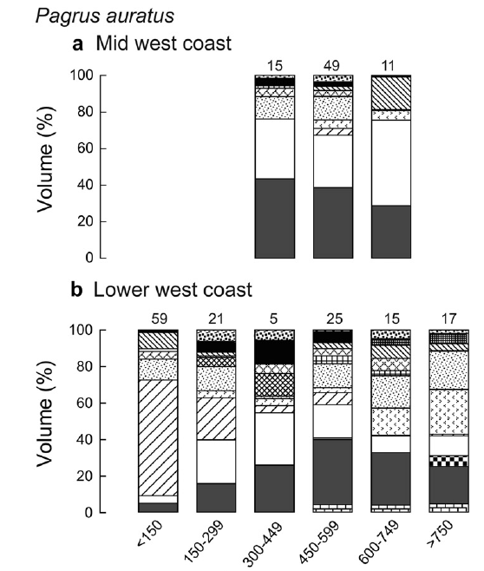 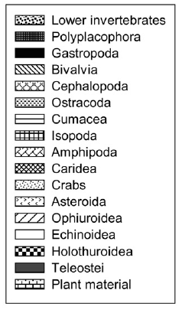

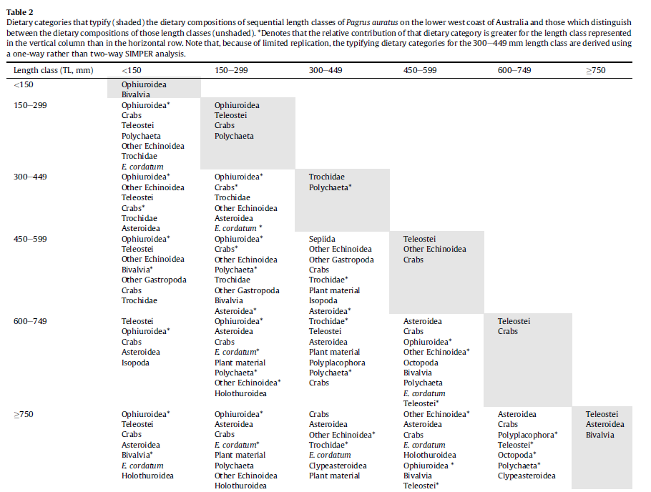

# > 150 mm

|  |  |
| --- | --- |
| **prey item** | **probability of consuming** |
| BFF bivalve | 0.1 |
| BD ophiuroids, echinoids | 0.3 |
| FSR small | 0.05 |
| FLR small | 0.05 |
| FMA small | 0.05 |
| FDC small | 0.05 |
| CEP cephalopod | 0.05 |
| BG echinoids | 0.3 |
| MAZ crabs | 0.1 |

# 150-299 mm

|  |  |
| --- | --- |
| **prey item** | **probability of consuming** |
| BFF bivalve | 0.1 |
| BD ophiuroids, echinoids | 0.3 |
| FSR small | 0.05 |
| FLR small | 0.05 |
| FMA small | 0.05 |
| BC polychaets | 0.1 |
| FDC small | 0.05 |
| CEP cephalopod | 0.05 |
| BG echinoids, snails | 0.3 |
| MAZ crabs | 0.1 |
| PRW shrimps | 0.02 |

# 300-449 mm

|  |  |
| --- | --- |
| **prey item** | **probability of consuming** |
| BFF bivalve | 0.1 |
| BD ophiuroids, echinoids | 0.3 |
| FSR small | 0.05 |
| FLR small | 0.05 |
| FMA small | 0.05 |
| BC polychaets | 0.1 |
| FDC small | 0.05 |
| CEP cephalopod | 0.05 |
| BG echinoids, snails | 0.3 |
| MAZ crabs | 0.1 |
| PRW shrimps | 0.02 |

# 450-599 mm

|  |  |
| --- | --- |
| **prey item** | **probability of consuming** |
| BFF bivalve | 0.01 |
| BD ophiuroids, echinoids | 0.15 |
| FSR medium | 0.3 |
| FLR medium | 0.3 |
| FMA medium | 0.3 |
| BC polychaets | 0.1 |
| FDC medium | 0.3 |
| CEP cephalopod | 0.05 |
| BG echinoids, snails | 0.15 |
| MAZ crabs | 0.2 |
| PRW shrimps | 0.05 |

# 600-749 mm

|  |  |
| --- | --- |
| **prey item** | **probability of consuming** |
| BFF bivalve | 0.01 |
| BD ophiuroids, echinoids | 0.1 |
| FSR medium | 0.3 |
| FLR medium | 0.3 |
| FMA medium | 0.3 |
| BC polychaets | 0.1 |
| FDC medium | 0.3 |
| CEP cephalopod | 0.2 |
| BG echinoids, snails | 0.15 |
| MAZ crabs | 0.15 |
| PRW shrimps | 0.05 |

# > 750 mm

|  |  |
| --- | --- |
| **prey item** | **probability of consuming** |
| BFF bivalve | 0.01 |
| BD ophiuroids, echinoids | 0.1 |
| FSR medium | 0.25 |
| FLR medium | 0.25 |
| FMA medium | 0.25 |
| BC polychaets | 0.1 |
| FDC medium | 0.25 |
| CEP cephalopod | 0.3 |
| BG echinoids, snails | 0.15 |
| MAZ crabs | 0.15 |
| PRW shrimps | 0.05 |